Our suggested tattoo procedures as well as the possible extra covid pandemic precautions are as follows
Prior to setting up for a procedure artist shall wash hands and wrists with a germicidal/bactericidal soap. This process shall be a minimum of 30 seconds making sure to scrub under nails, between fingers and backs of hands. Once hands are washed, rinsed and dried with paper towel then use paper towel to turn off faucet.
Next we ask client if there are any allergies we should know about, then we put on appropriate gloves and set up our work area, this involves covering everything in a plastic protective barrier, such as but not limited to tattoo machine, power cord, bottles, armrest, power supply, etc.… as seen below in picture: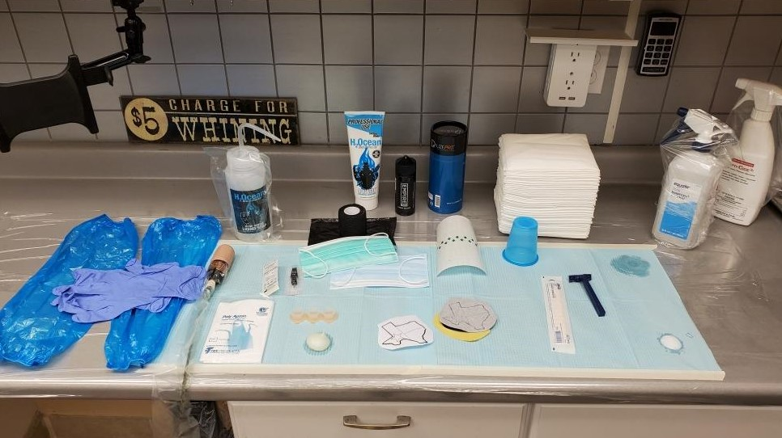
Next, we dispose of gloves and put a new pair on and prepare client for tattoo, (of course the client and artist will have already had masks on FYI)
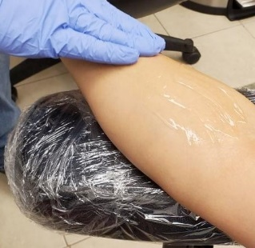
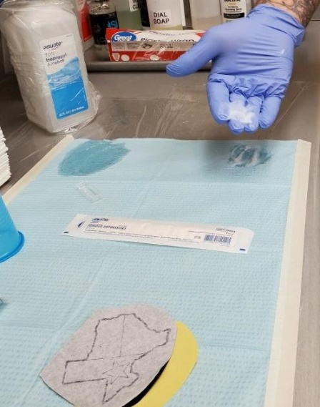
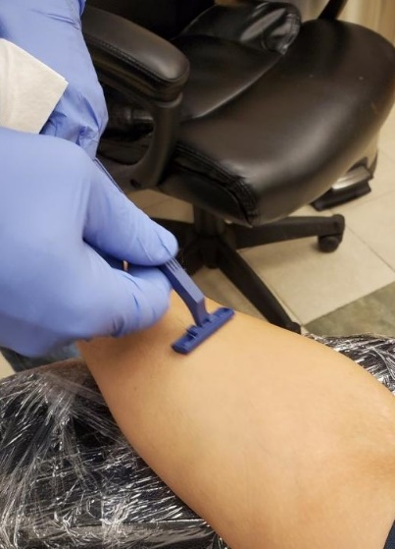
Next the artist will scrub the area on client to be tattooed with an approved germicidal/bactericidal soap. Once skin is clean the artist will shave area to be tattooed with a single service disposable razor. Next the artist will apply an alcohol-based sanitizer to tattoo area prepping it to receive stencil, once dry the artist will apply approved stencil solution from pre poured source, apply stencil then allow to dry.
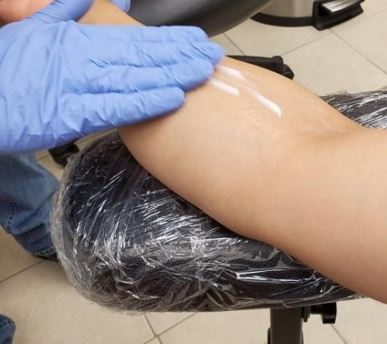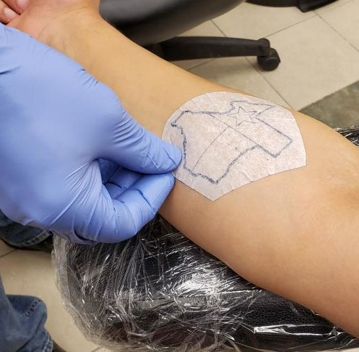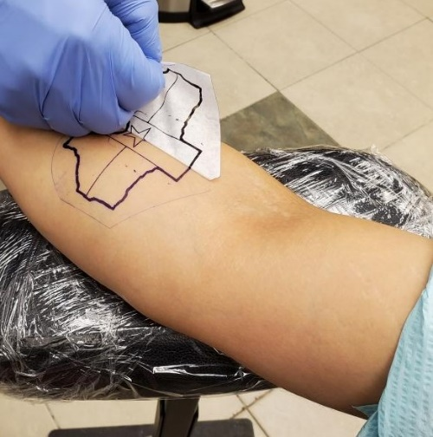
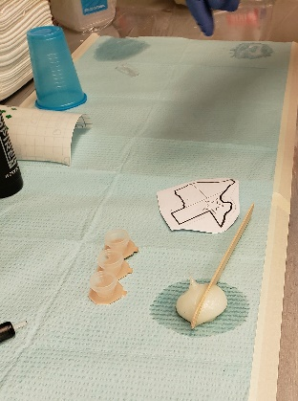
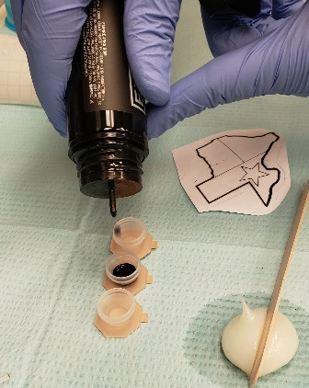
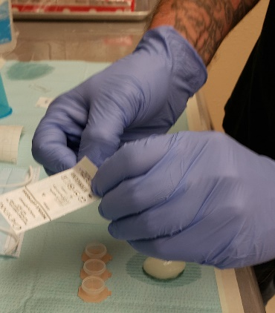
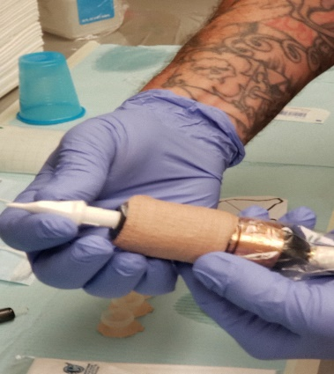
Once this is done, we remove dirty gloves and put a new pair on to open needle cartridges to tattoo, all needles/needle cartridges are new, and EO gas sterilized from manufacturer. We install needle cartridge in tattoo machine pour tattoo ink in disposable ink cup and are ready to tattoo.
Next artist discards gloves and puts new gloves on then poly arm sleeves and poly apron, applies tattoo ointment then applies tattoo on client. Notice at no time in this process does the artist skin touch clients skin, THERE IS ALWAYS A PROTECTIVE BARRIER BETWEEN CLIENT AND ARTIST.
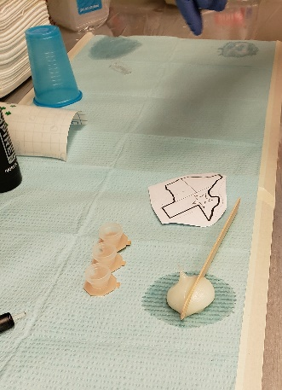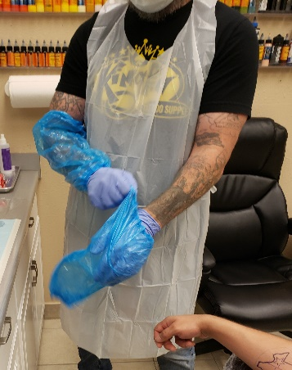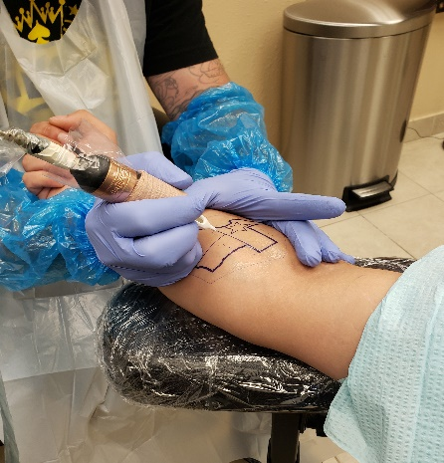
Once tattoo procedure is finished artist then wipes tattoo area clean with approved germicidal/bactericidal soap, applies a small amount of tattoo ointment such as bacitracin discards dirty gloves and puts a new pair on and applies a clear tagaderm type skin barrier or a nonstick bandage. After this client is told oral aftercare procedures and given written aftercare procedures to take home and artist begins tear down of work area.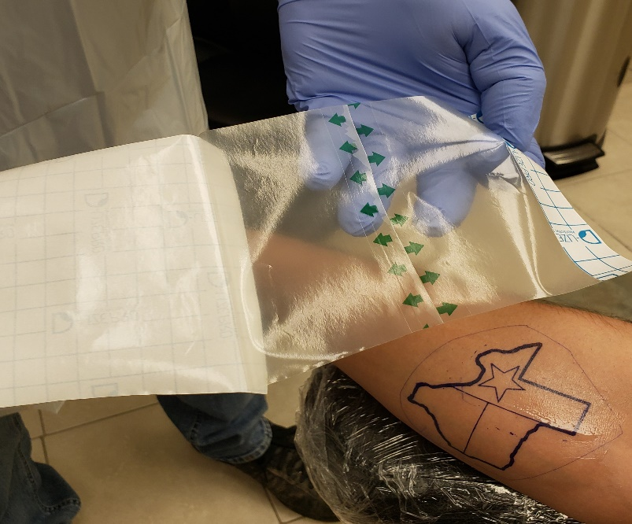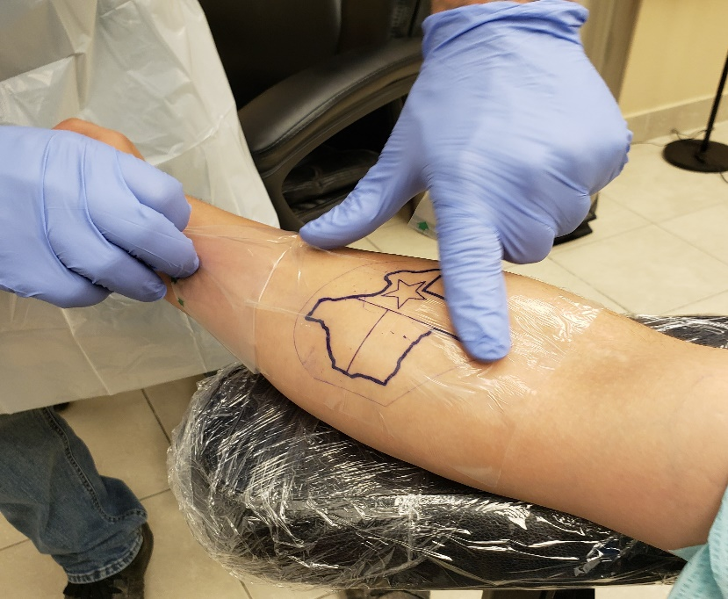 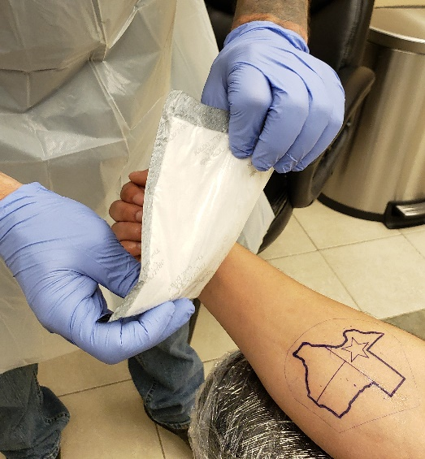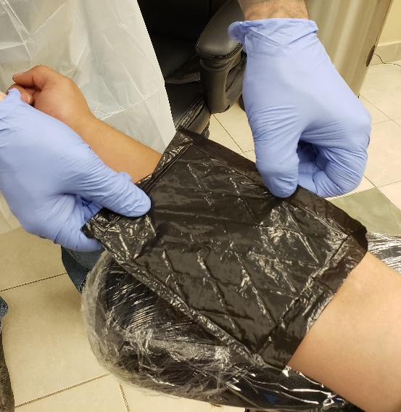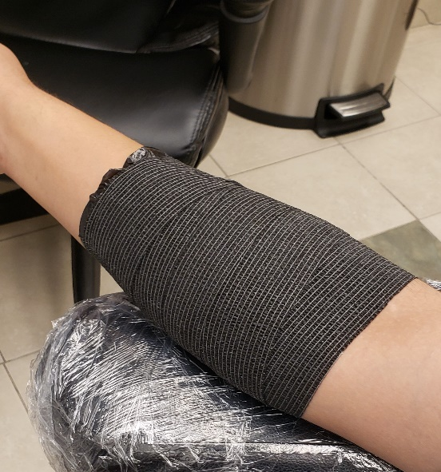
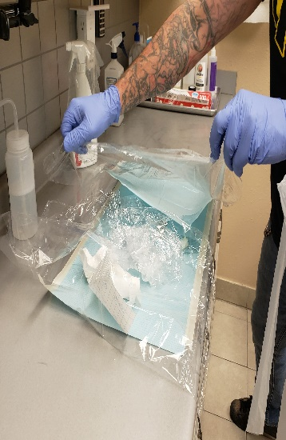
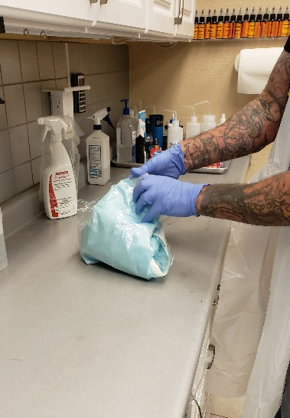
The cleaning of work are is as follows while wearing a clean pair of gloves the artist removes plastic barriers from all bottles , armrests and discards, removes needle cartridges from tattoo machine and disposes into a medical sharps container, removes plastic barriers from machine and power cord, discards all waste into garbage, and sprays approved virucide/disenfectant on everything and wipes machine and cord with virucide/disenfectant. 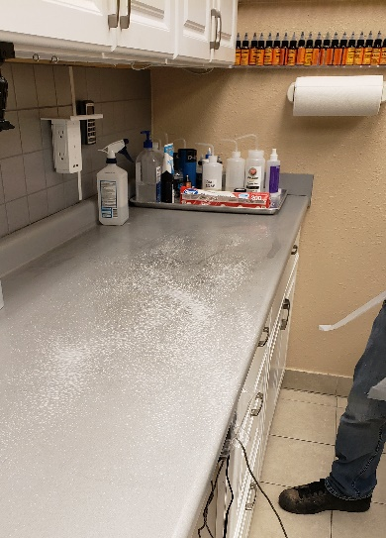
I hope this helps you understand our tattoo procedures , this is our standard practice we were doing for the covid pandemic before we got closed down by Govornor Abbott,in addition to only allowing one client per artist in procedure room, Services done by appointment only.
After much contemplating on the subject we have some suggestions that may help you guys help us open in a safe and responsible manner.
Screen clients and staff members upon arrival to studio
Appointment only until appropriate phase
One client per artist in room and if studio is an open air studio then work areas a minimum of 6 to 8 feet apart.
Everyone in building must wear face masks, that is clients and staff members.
Minimum standards on ppe should be at least face masks, poly arm sleeves (as needed per artist),poly aprons, all equipment covered with plastic barriers
Take temperature of all clients and staff members upon arrival, and record on client paper work.
Most reputable studios already operate with many of these procedures if not all. You will find that studios generally use spore tested hospital grade autoclaves to sterilize any equipment that is not disposable. We are also trained in infectious disease control, blood borne pathagens (which is not required by the state but should be), first aid and cpr. We are licensed by the Texas Health Department and our buildings, practices and procedures have already been cleared and approved through health department guidelines and inspections.
We would like to thank you for the priveledge and opportunity to have a voice in this, we are happy to work with you in any way you need us to in order to allow us to open safely asap. Many business owners and artists are struggling and losing their livelihoods as we speak, and we truly cant hang on much longer….we ask that you consider the information that we have provided and hopefully it will show you that we are capable of opening our businesses and protecting our community and fellow Texans at the same time.
We appreciate your time and are here if you need anything or have any questions,
Representing the tattoo community of the great state of Texas,

Randall Doolittle Ryan Green
randall.doolittle@gmail.com tattoosbyryangreen@gmail.com
409-719-2320 409-499-0905
Flipper’s Skin Flix Tattoo All About Art Tattoo
1060 Texas Ave. 863 South Main
Bridge City, TX, 77611 Lumberton,TX, 77657

